

**SOFTWARE USER GUIDE**

*RS GRAVADOR ESTIMATE*

(A Cost Estimating and Report Generating Software of RS Gravador Builders)

1. **Parts of the Software**

Initial Window:

Close Button

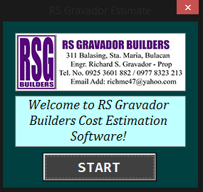

Start Button

Main Window:

Parts Selection

Project Details Form

Help Button

Pricelist Button

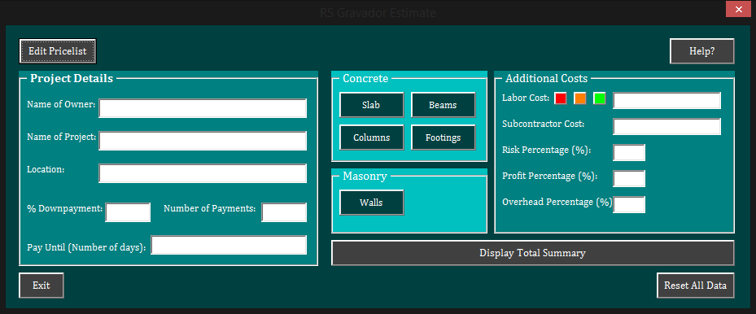

Additional Costs

Fill-up Form

Total Summary Button

Reset Button

Exit Button

Pricelist Window:

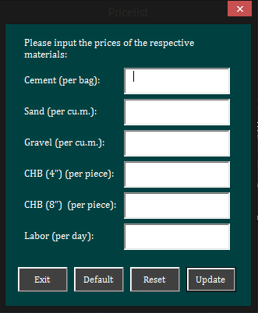

Price Fill-up Forms

Update Button

Reset Button

Default Button

Exit Button

Estimation Window:

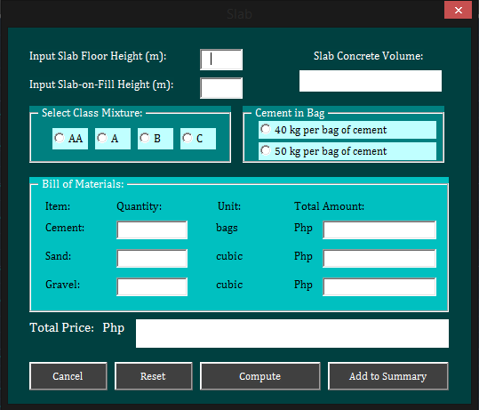

Total Price

Display

Sub Summary Button

Compute Button

Reset Button

Cancel Button

Bill of Materials

Display

Cement in Bag

Selection

Class Mixture

Selection

Volume Display

Height Text-box

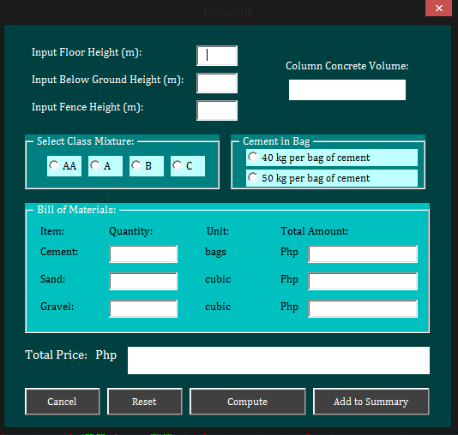

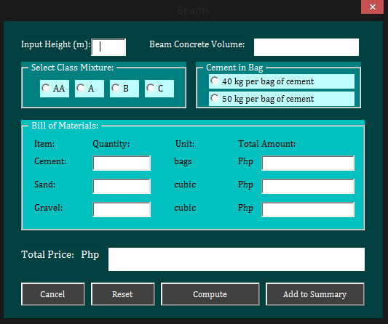

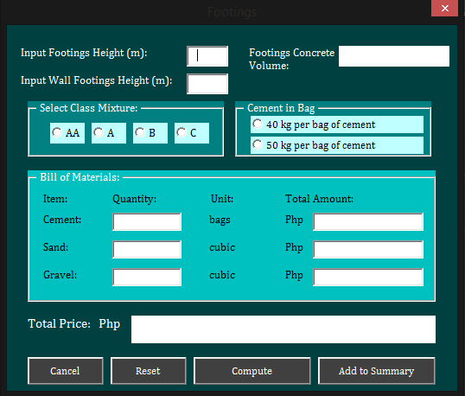

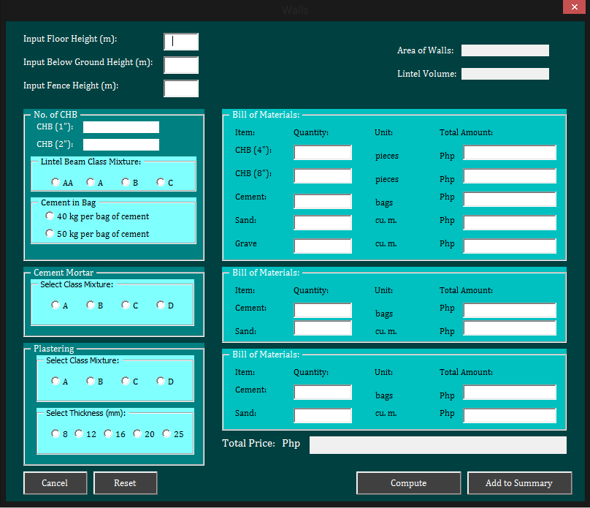

Area Display

Plaster Thickness Selection

Summary Window:

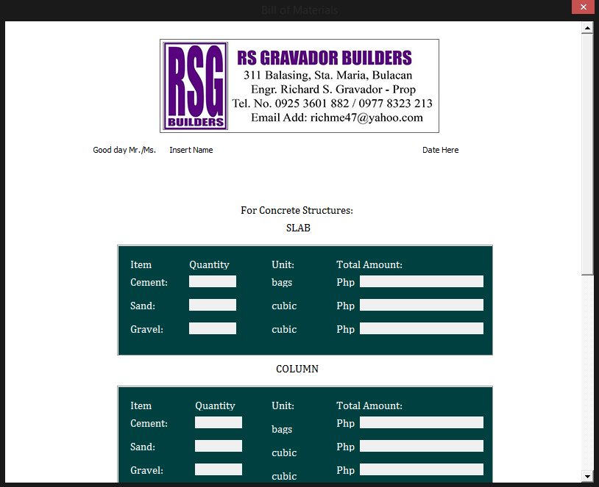

Scroll Bar

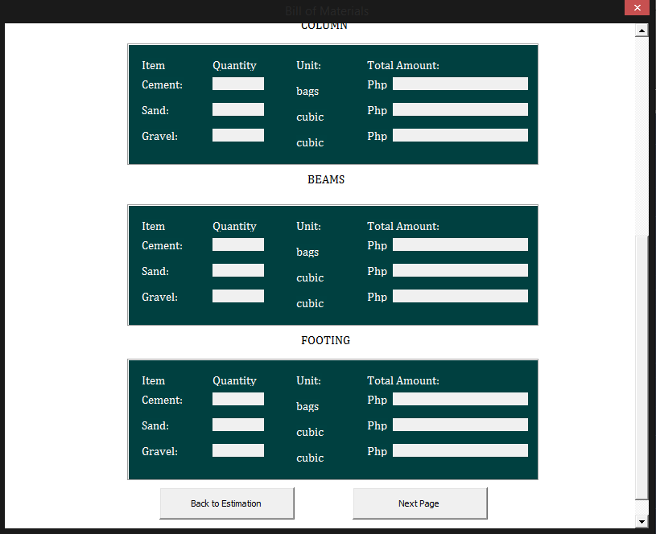

Next Page Button

Back Button

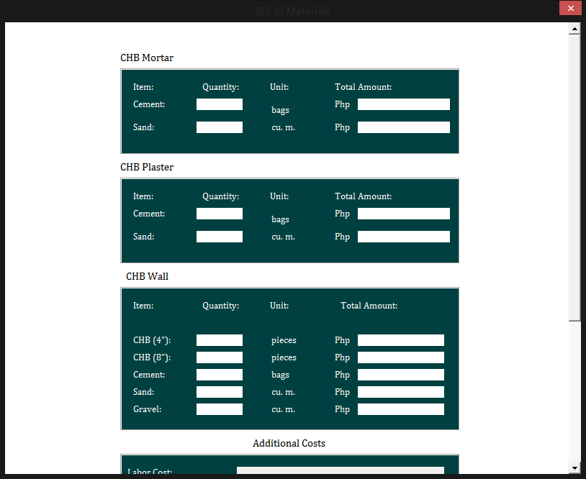

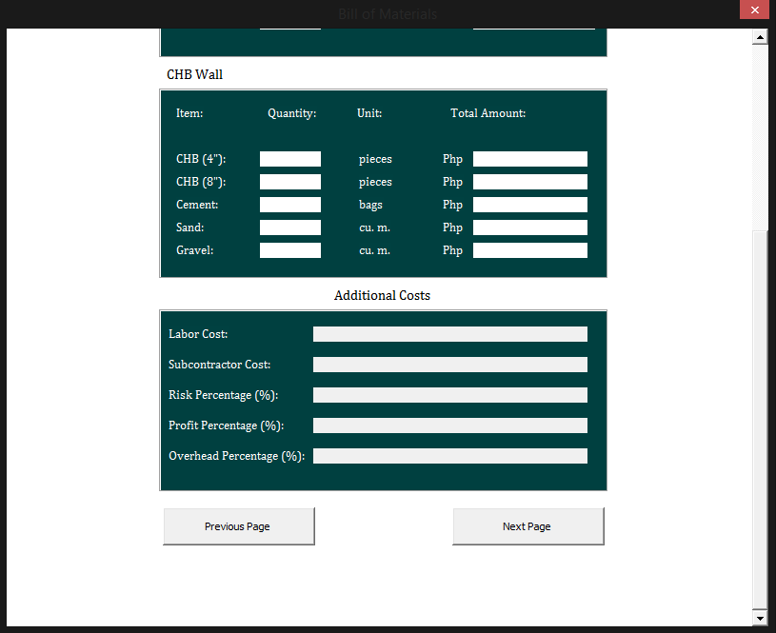

Previous Button

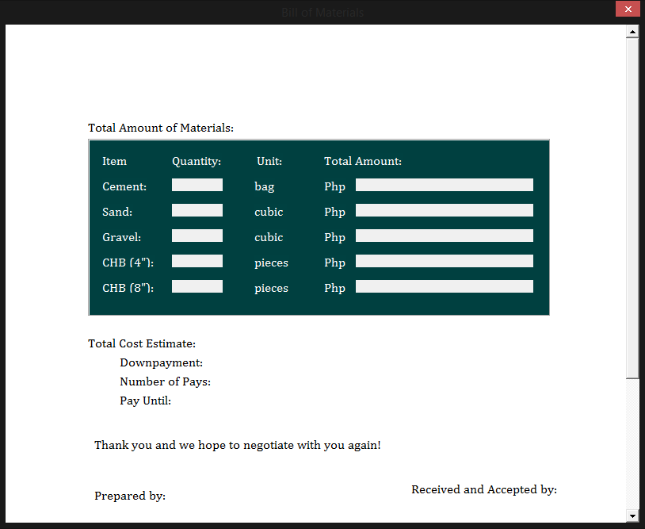

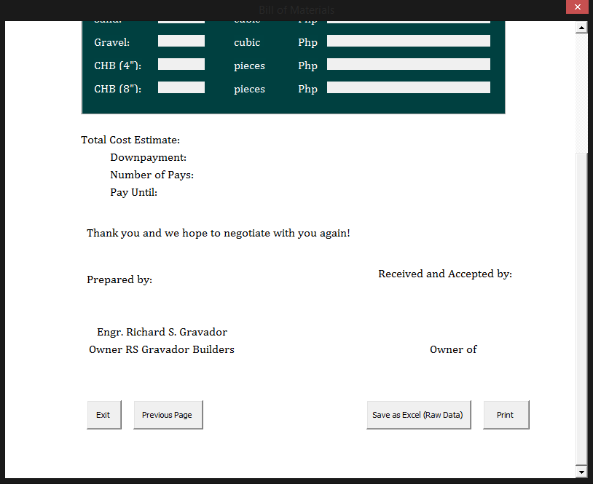

Save Button

Print button

Exit Button

Paper Sizes Window:

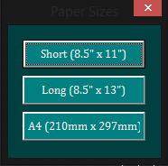

1. **Functions of the Windows and its Components**

Windows:

1. Initial Window – start-up screen of the program
2. Main Window – fill-up forms of the project details and additional costs, as well as the selection buttons of the parts of the structure
   1. Pricelist Window – where the user may edit the prices of the materials
3. Estimation Window – estimation window of the structures by the inputting of height and selecting class mixtures and specifications
4. Summary Window – generated report of the total estimation of RS Gravador Builders. Printing and Save buttons are also available in this window.
   1. Paper Sizes Window – where the user may select the paper sizes for the generated report printing

Buttons:

1. Close Button – closes the active window
2. Start Button – starts the program and direct to the main window
3. Pricelist Button – opens the pricelist window
4. Project Details Form – where the user will input the project name, project owner, project location, percent down payment, number of pays, and pay until (number of days)
5. Parts Selection – selection of the parts of the structure namely, slab, column, beam, footings, and walls
6. Help Button – opens the user guide for the application
7. Reset Button – resets all values in the form
8. Total Summary Button – displays the total summary of the project and generate its report
9. Additional Costs Fill-Up Form – where the user will select a labor cost and input subcontractor costs, risk percentage, overhead percentage, and profit percentage
10. Price Fill-Up Forms – where the user will input the prices of the materials
11. Exit Button – exits the pricelist window to the main window
12. Default Button – inputs the default prices of the materials
13. Update Button – updates the prices for the materials
14. Height Textbox – where the user will input the height for the computation of the volume and/or area of the selected part of the structure
15. Class Mixture Selection – where the user will select from Class AA, A, B, C, or D
16. Volume Display – displays the total volume of the selected part
17. Cement in Bag Selection – where the user will select from 40 kg or 50 kg cement in bag
18. Area Display – displays the total area of the selected part
19. Plaster Thickness Selection – where the user will select from 8, 12, 16, 20, or 25 mm thickness of plaster
20. Bill of Materials Display – displays the quantity and price of each material
21. Cancel Button – exits the form to the main window
22. Compute Button – performs the estimation of RS Gravador Builders
23. Sub Summary Button – adds the results per each part to the total summary
24. Total Price Display – displays the total price of the selected part
25. Scroll Bar – allows the user to scroll and view the lower parts of the window
26. Back Button – returns the program to the main window
27. Next Page Button – turns the window to the next page
28. Previous Page Button – returns the window to the previous page
29. Save Button – saves the generated report as a raw file (without formatting) in MS Excel
30. Print Button – prints the generated report of the program
31. Exit Button (Main and Summary) – ends the program completely
32. **Procedure**
33. Click the start button on start-up to begin.
34. Click on the Edit Pricelist button to update the prices of your materials.
    1. Enter your desired prices on each respective box. You may click the Default button to automatically add the default prices of the materials.
    2. Click update to save your prices.
       1. You can click the reset button to clear your changes if you had a mistake or not satisfied with your input.
    3. Click the exit button to after saving your changes. You will be redirected again to the main window.
35. Fill up the project details of your work.
    1. Please refrain from using special characters and letters on the % Down payment and Number of Payments section. This may cause a miscalculation in your work.
36. After that, select one of the structures to be computed. You will be directed to their respective windows.
37. 5.1 For Concrete Structures
    1. Input the height of the selected part.
    2. Select Class mixture.
    3. Select the quantity of cement in bag.
    4. Click compute button if you are done.
       1. You can click the reset button to clear your changes if you had a mistake or not satisfied with your input.
    5. Click the Add to Summary button to store the computed values for later viewing and saving.
    6. Click Cancel button after securing your data as you wish. You will be redirected to the main window.

5.2 For Masonry:

1. Input the height of the walls.
2. Select class mixture and quantity of cement in bag of lintel beams.
3. Select class mixture of cement mortar.
4. Select class mixture and thickness of plaster.
5. Click compute button if you are done.
   1. You can click the reset button to clear your changes if you had a mistake or not satisfied with your input.
6. Click the Add to Summary button to store the computed values for later viewing and saving.
7. Click Cancel button after securing your data as you wish. You will be redirected to the main window.
8. Pick a productivity rate for your labor cost.

a. Red - low productivity

b. Orange - medium productivity

c. Green - high productivity

1. Fill up the remaining fields. Please refrain from using special characters and letters in the remaining areas to avoid miscalculations.
2. Click on the Display Total Summary Button on the bottom right corner of your window.
   1. You may click on the Reset All Data button on the bottom left corner if you are not satisfied with your input.
3. Review your generated summary.
4. On the last page, you have the choice of printing, saving, or both.

10.1 Printing

1. Click the Print button on the right side of the window.
2. Select your paper size and make sure a printer is connected.
3. The program will directly print your summary.

10.2 Saving

1. Click the Save as Excel button on the center of the window.
2. MS Excel will open with your new workbook and data from your estimate on the software, and ready to save.

*Please take note that the generated sheets are raw, thus lacking aesthetic formatting because this is for database

1. **Limitations of the Software**
2. The software is good only for the same floor-to-floor height each level.
3. Data exported on excel are raw data, thus having no formulas and purposely done for storing only.
4. The software only caters 2 types of CHB. Any other type present in a floor plan will result to a miscalculation.
5. The software is designed solely on the existing CAD layering of RS Gravador Builders.
6. This software is exclusively for RS Gravador Builders ONLY. Other plans from other companies are not solvable by this software.